
Student Name: IMMACULATE MUTHEU MULI
Admission Number: BSCCS/2024/33678
Course/Class: COMPUTER SCIENCE JANUARY 2024
Unit Code: BIT3208
Unit Name: ADVANCED WEB DESIGN AND DEVELOPMENT
Lecturer Name: MR. MICHAEL NYORO
Semester/Academic Year: FOURTH YEAR
Project Title: TechHive Ecommerce
Technologies Used
- PHP (server-side scripting)
- MySQL (relational database)
- HTML5 and CSS3 (structure and styling)
- Bootstrap 5 (responsive UI framework)
- JavaScript (frontend validation and interactivity)
- XAMPP (local development environment)
- Figma (UI/UX design and prototyping)
- Git and GitHub (version control)
Github Link
https://github.com/immaculatemuli/techhive_ecommerce.git
Figma prototype
https://www.figma.com/proto/kyLIU8WNEGKgExbtIBhopj/ecommerce?node-id=439-56&t=KH27XvfCzOfKu22w-1&scaling=min-zoom&content-scaling=fixed&page-id=0%3A1&starting-point-node-id=383%3A1536
Figma File
https://www.figma.com/design/kyLIU8WNEGKgExbtIBhopj/ecommerce?node-id=383-1256&t=sOvq4IAF4Ru1EWtG-1
Table of Contents
Week 1: Local Environment Setup 3
Fig 1: Installation of XAMPP 3
Fig 2: Apache and MySQL Running 3
Fig 3: Localhost Test Page (HTML page) 3
Fig 5: Database Connection Test 4
Week 2: Wireframes and GUI Design 5
Fig 1: Low fidelity Wireframes 5
Fig 2: Color Theme 7
Fig 3: TechHive Navigation Structure 8
Fig 4: Mobile View Mockup 10
Fig 4: GUI Prototype in Figma 11
Week 3: JavaScript and PHP Basics 15
Fig 1: JavaScript Form Validation 15
Fig 3: PHP Syntax Practice 16
Fig 4: Database Connection Script 16
Fig 5: Dynamic User Input Handling 17
Week 4: Authentication System 18
Fig 1: Login form 18
Fig 2: Registration form 18
Fig 3: Simple Authentication System 19
Fig 4: Backend Folder Structure 20
Week 5: Database Components and CRUD Operations 21
Fig 1: Database Creation 21
Fig 2: Creating Tables 21
Fig 3: CRUD Operations 22
Fig 4: PHP to Database Connection 23
Fig 5: Fetching Database Records 23

Week 1: Local Environment Setup
Title: Installation and Testing of Local Development Environment

Fig 1: Installation of XAMPP
(i had already installed XAMPP)
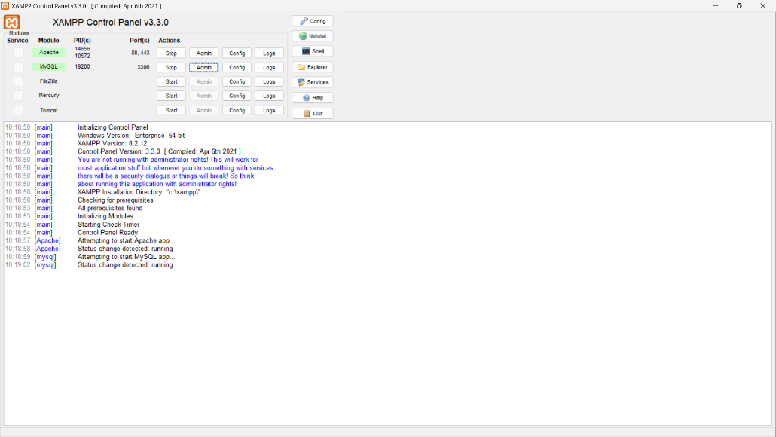

Fig 2: Apache and MySQL Running


Fig 3: Localhost Test Page (HTML page)
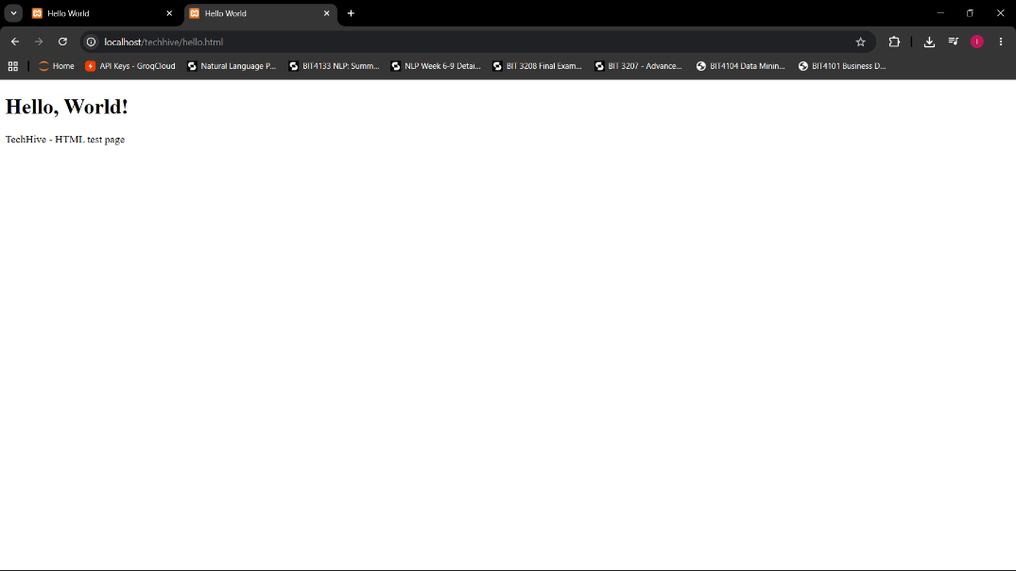

Fig 4: Hello World Test (PHP page)
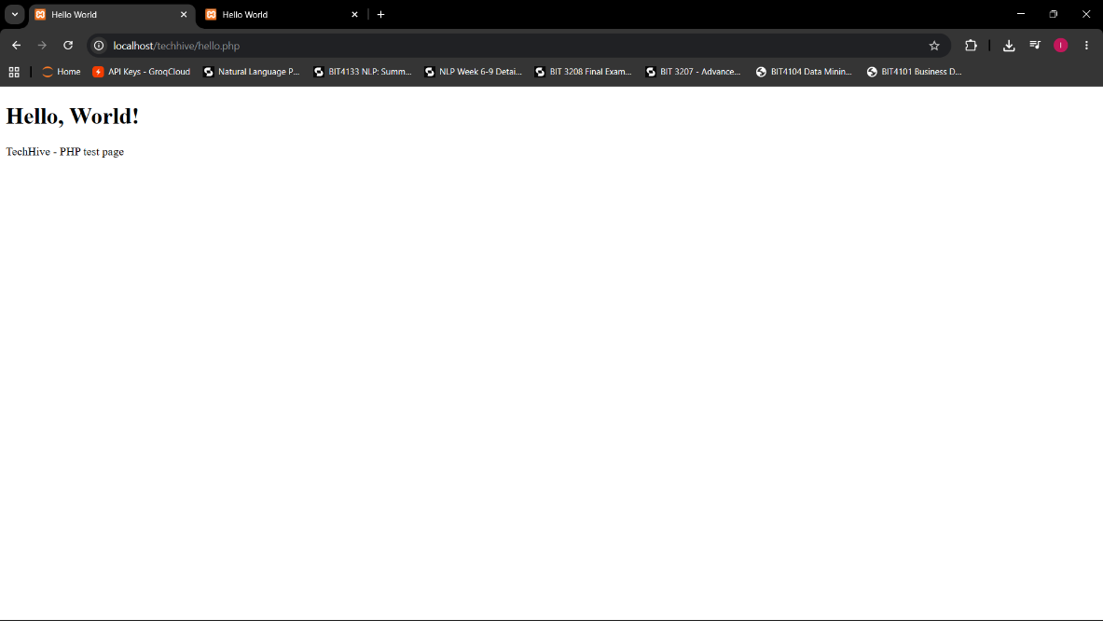

Fig 5: Database Connection Test
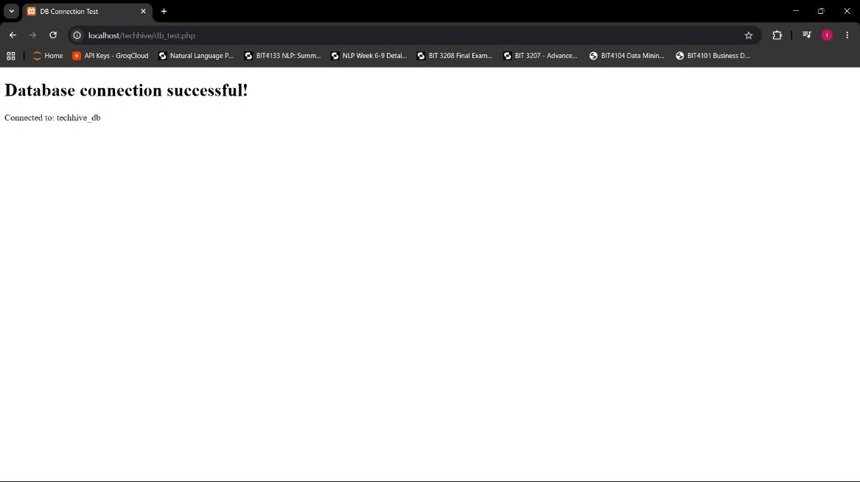
I set up my local development environment using XAMPP. Fig 1 shows the XAMPP control panel confirming successful installation on my machine. Fig 2 demonstrates Apache and MySQL services running, proving the server is active and ready to handle PHP requests. Fig 3 shows a localhost HTML test page, confirming Apache correctly serves static files through the browser. Fig 4 displays a PHP "Hello World" output, verifying that the PHP engine is properly configured and executing server-side code. Fig 5 shows a successful mysqli_connect() database connection, confirming PHP and MySQL are communicating correctly within the XAMPP environment.

Week 2: Wireframes and GUI Design
Title: User Interface Planning and System Design

Fig 1: Low fidelity Wireframes

1.1 Sign in wireframe
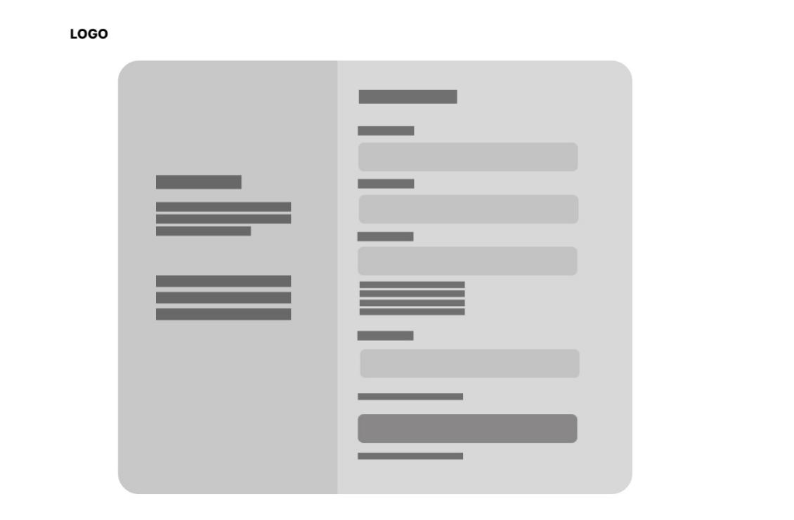
1.2 Sign up wireframe

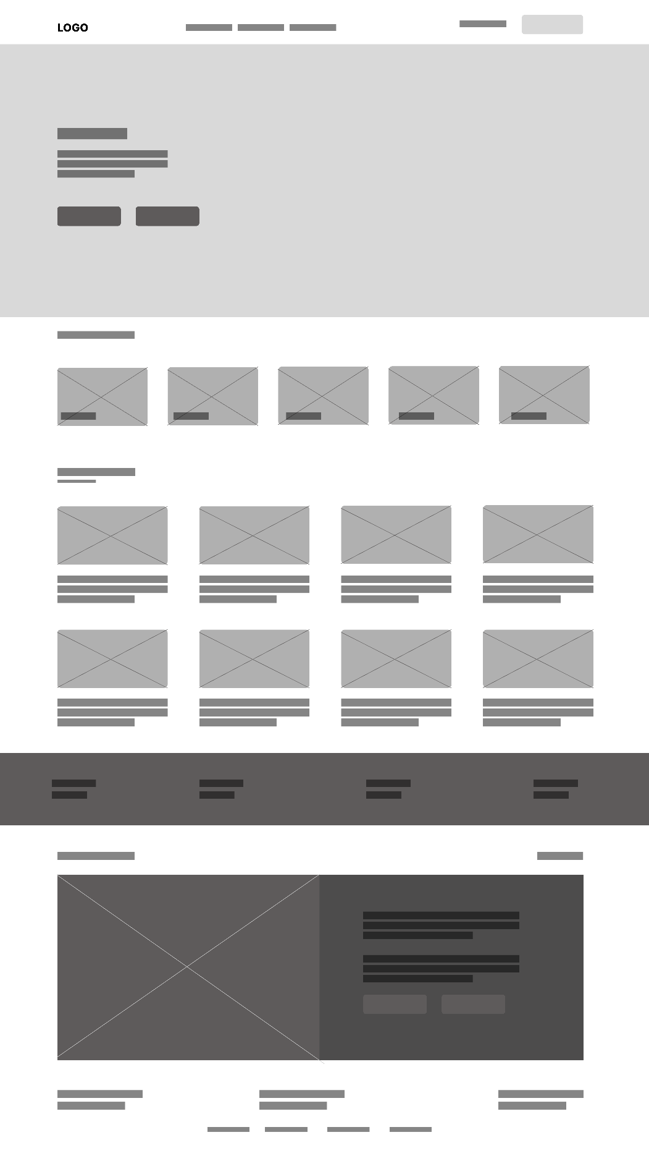
1.3 Homepage wireframe

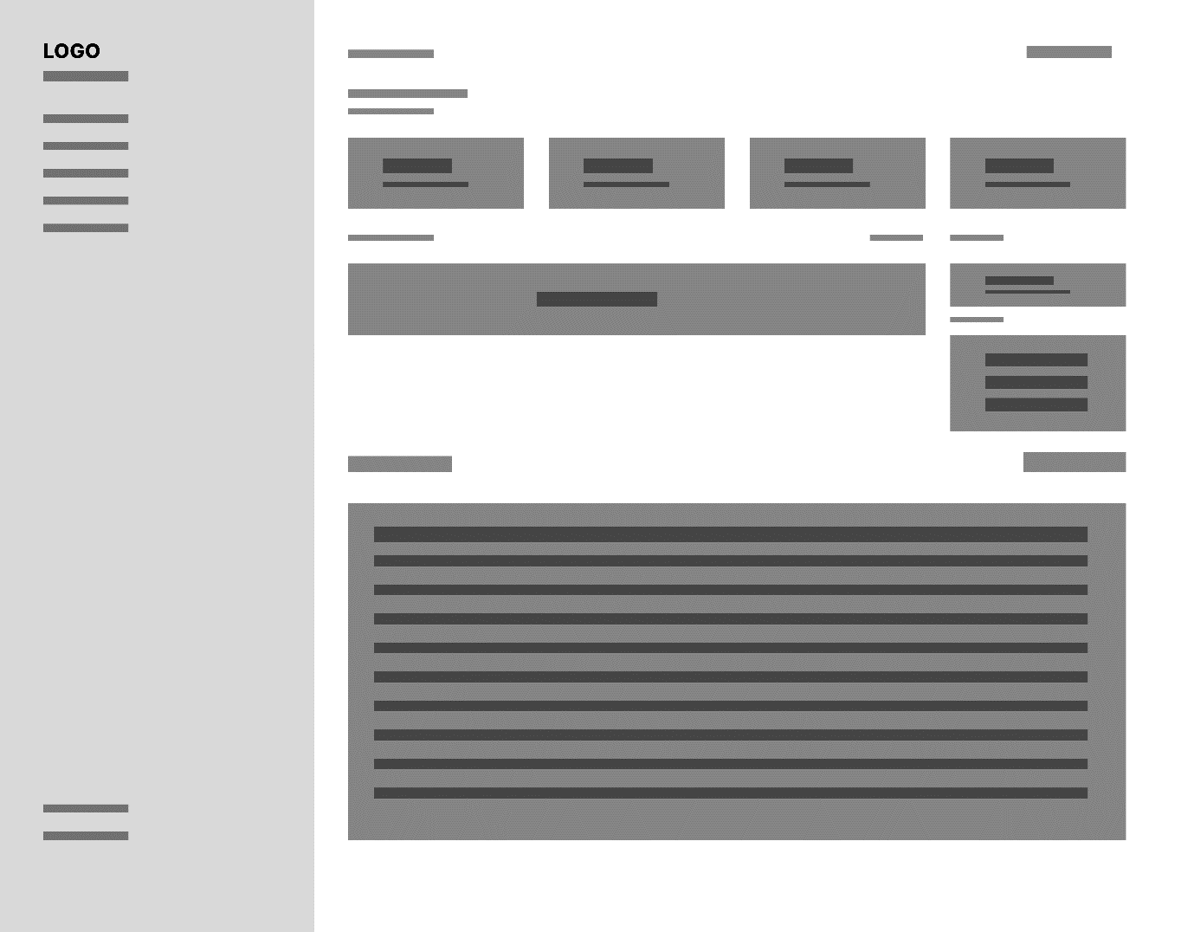
1.4 Dashbaord wireframe

Fig 2: Color Theme

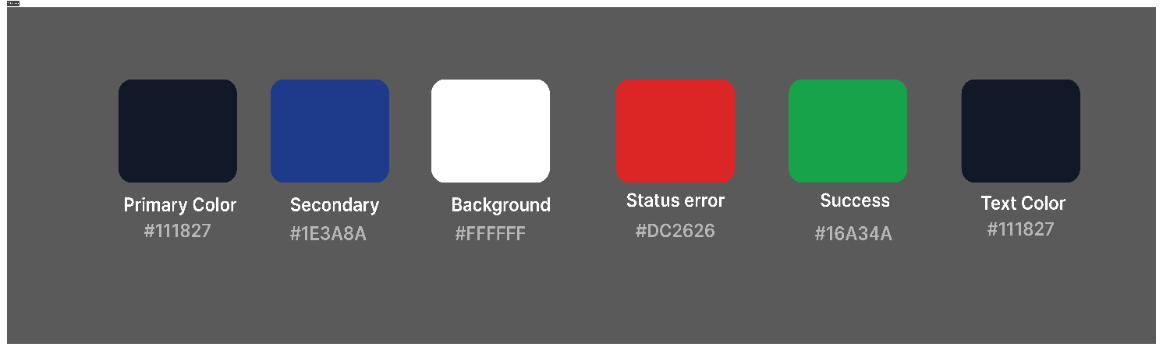

Fig 3: TechHive Navigation Structure
1. Public (Not Logged In)
Home
index.php
 | Products  products/index.php |  | Cart  cart.php |  |  | Sign In  login.php |  |  | Get Started  register.php
 | Filter / Search  by category |  | Sign in to Checkout  → redirects to login

2. Customer (Logged In)
Home
index.php
 | Products  products/index.php |  |  | Cart  cart.php |  |  | Avatar → My Account  dashboard.php
 |  |  |  | Checkout  checkout.php |  |  | My Orders
Order Confirmation
order placed

Logout
logout.php

3. Admin (Logged In as Admin)
Home
index.php
 | Products  products/index.php |  |  | Cart  cart.php |  |  | Admin Panel  admin/index.php
 | Products Table  admin/index.php |  |  | Orders  admin/orders.php |  |  | Users  admin/users.php
 | Add / Edit / Delete  product CRUD |  |  | Filter + Update  order status |  |  | Change User Roles  admin/users.php
Logout
logout.php

Fig 4: Mobile View Mockup


Fig 5: GUI Prototype in Figma

Figma prototype
https://www.figma.com/proto/kyLIU8WNEGKgExbtIBhopj/ecommerce?node-id=439-56&t=KH27XvfCzOfKu22w-1&scaling=min-zoom&content-scaling=fixed&page-id=0%3A1&starting-point-node-id=383%3A1536
Figma File
https://www.figma.com/design/kyLIU8WNEGKgExbtIBhopj/ecommerce?node-id=383-1256&t=sOvq4IAF4Ru1EWtG-1
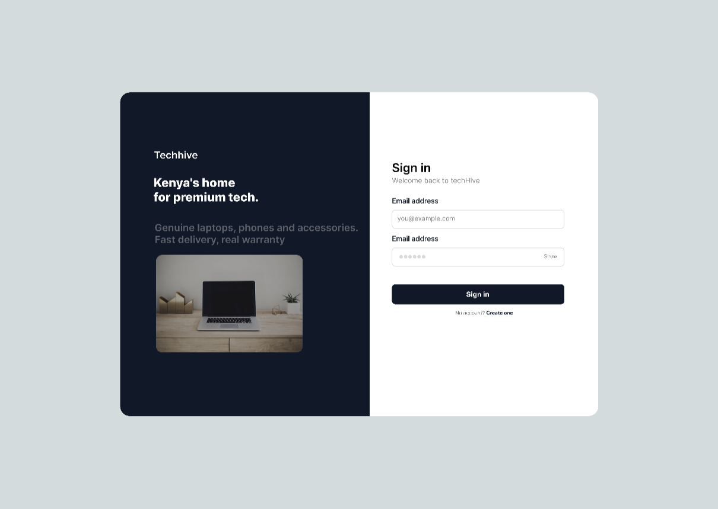
4.1: Sign in page

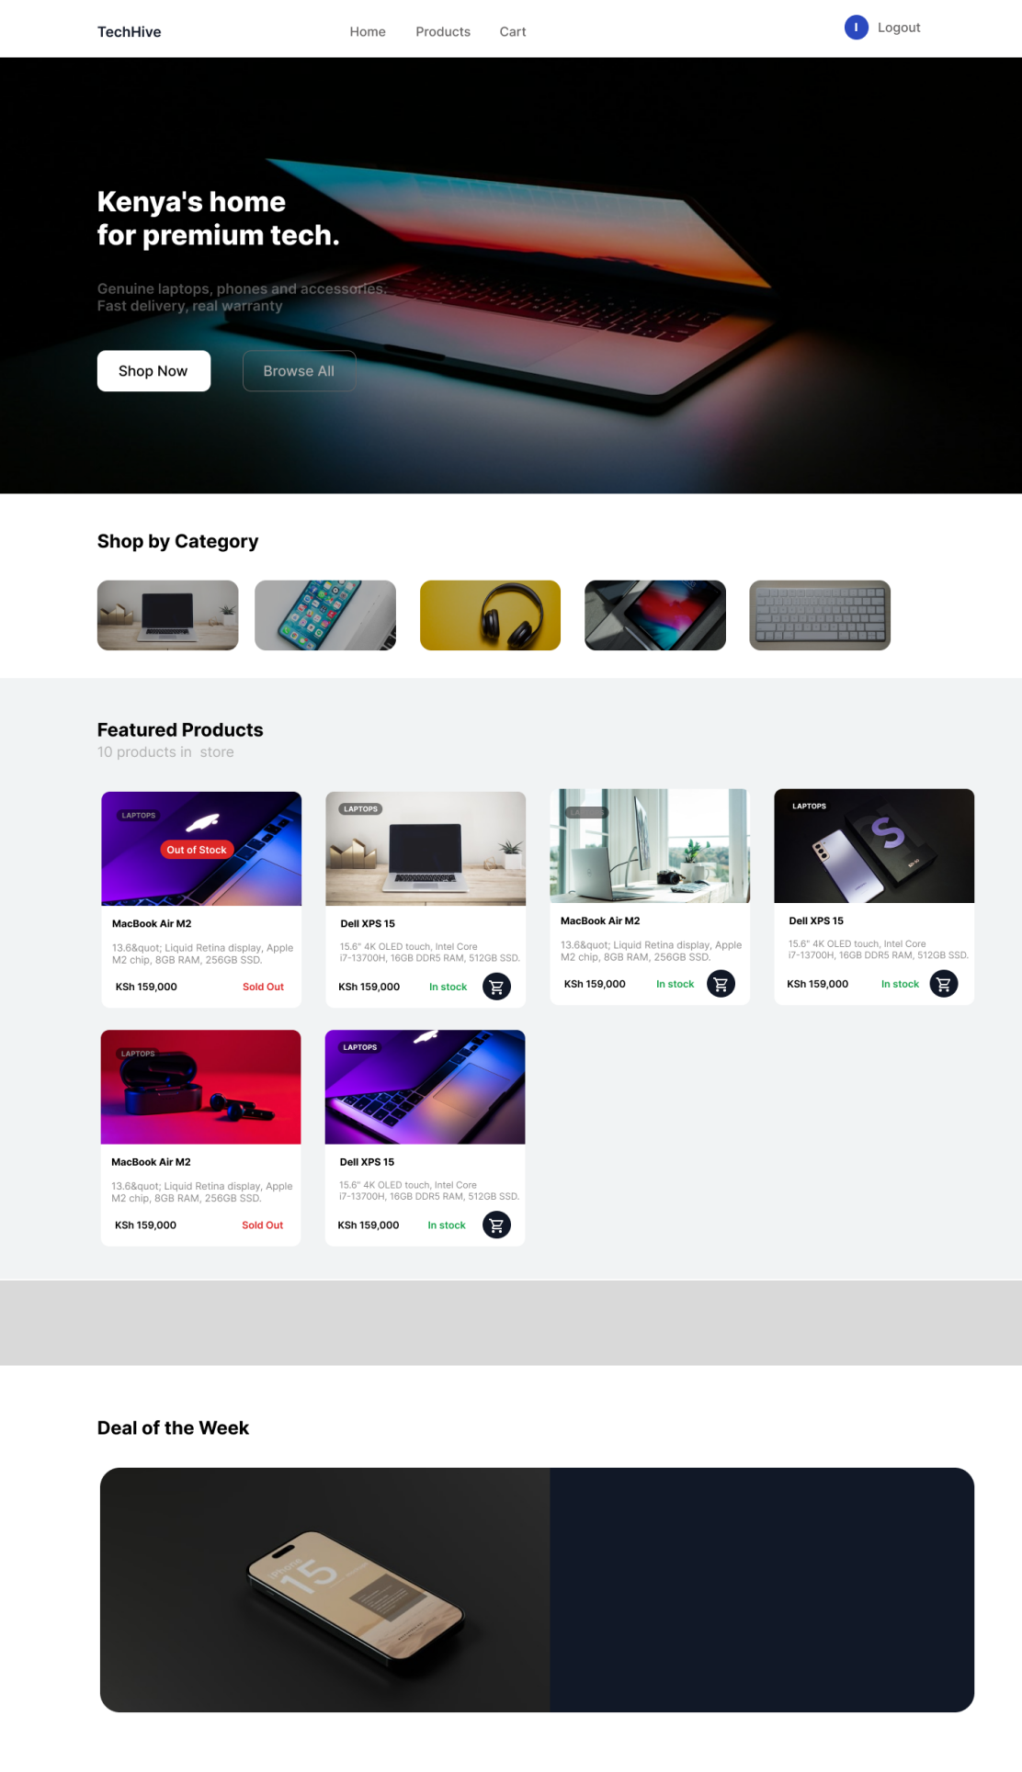
4.2: Homepage UI

4.3: Products page

4.4: Product details page
Fig 1 shows the low-fidelity wireframes designed in Figma covering the sign in page, sign up page, homepage and dashboard. Fig 2 shows the TechHive color theme built around a dark navy primary background to reflect a modern tech brand identity. Fig 3 shows the navigation structure diagram showing three user flows for Public, Customer and Admin navigation structure. Fig 4 shows the mobile view mockup confirming responsive layout considerations for small screens. The Figma prototype in Fig 5 applies the full color scheme and styling to the sign in page, homepage, products page and product details page showing the intended final user interface for TechHive.

Week 3: JavaScript and PHP Basics
Title: Frontend Interaction and Backend Foundations

Fig 1: JavaScript Form Validation
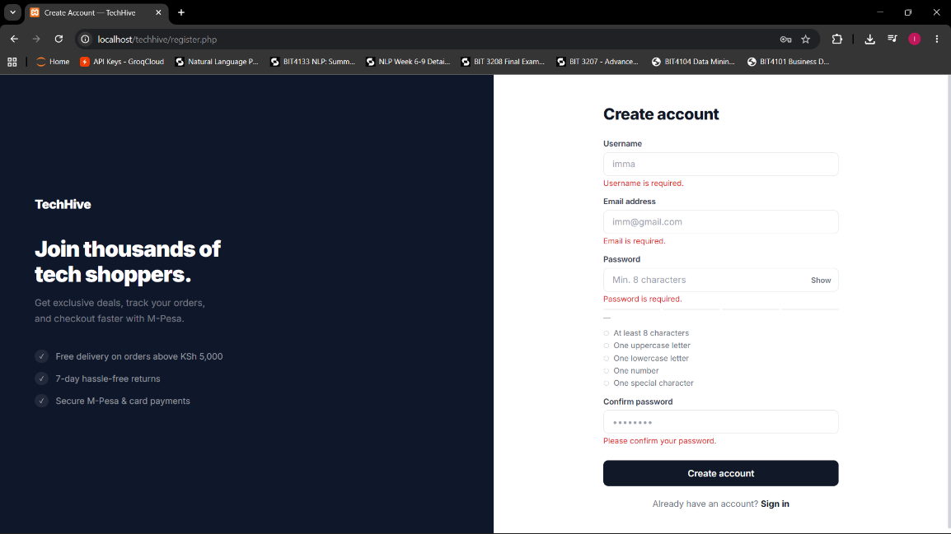

Fig 2: Password Strength Checker
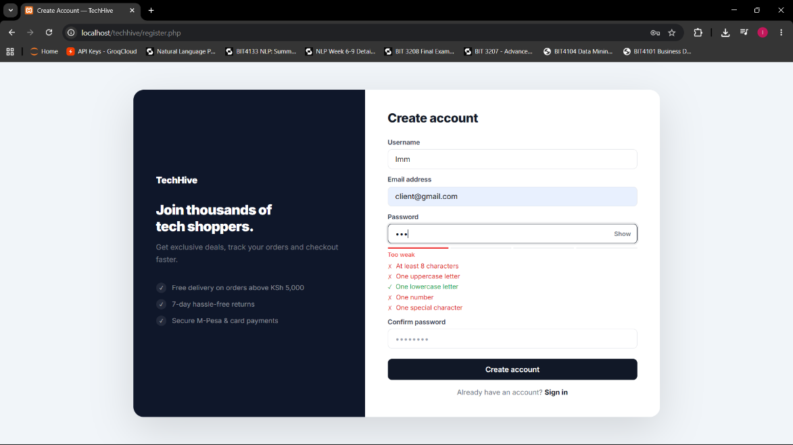
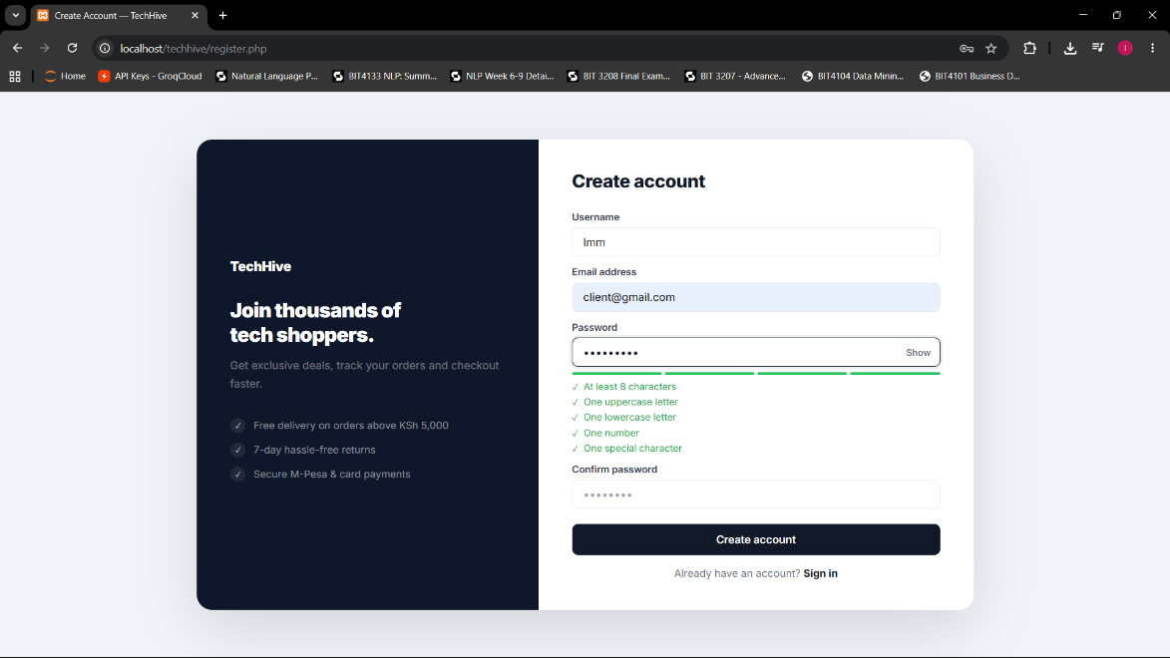

Fig 3: PHP Syntax Practice
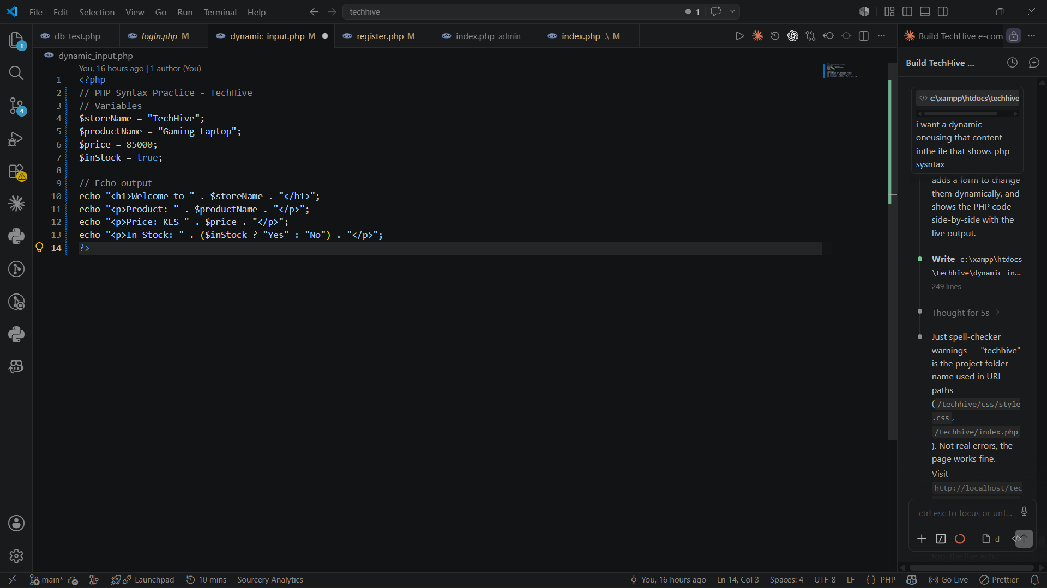

Fig 4: Database Connection Script
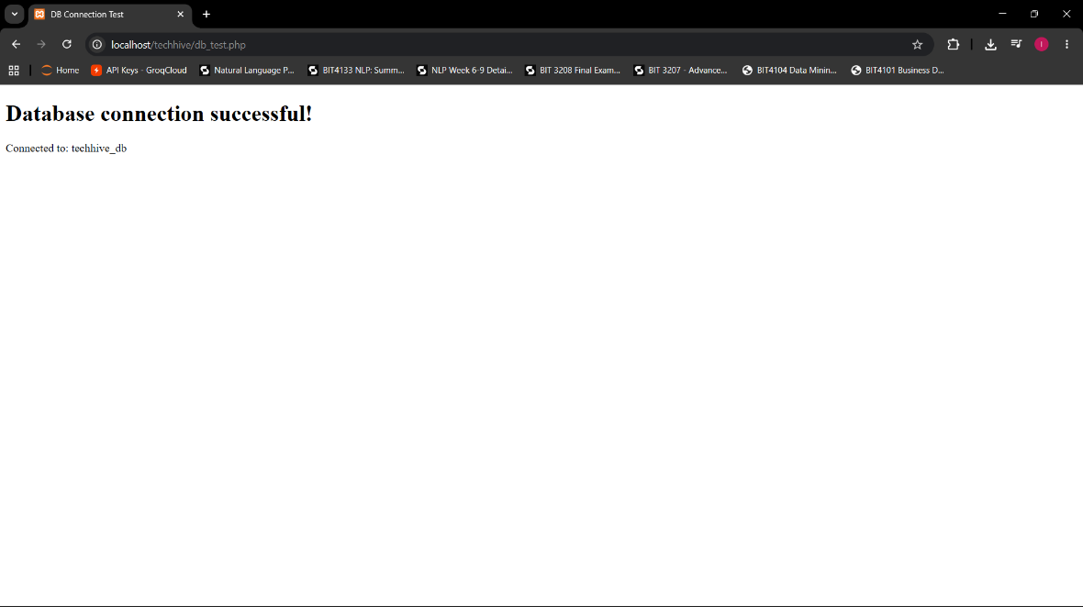

Fig 5: Dynamic User Input Handling
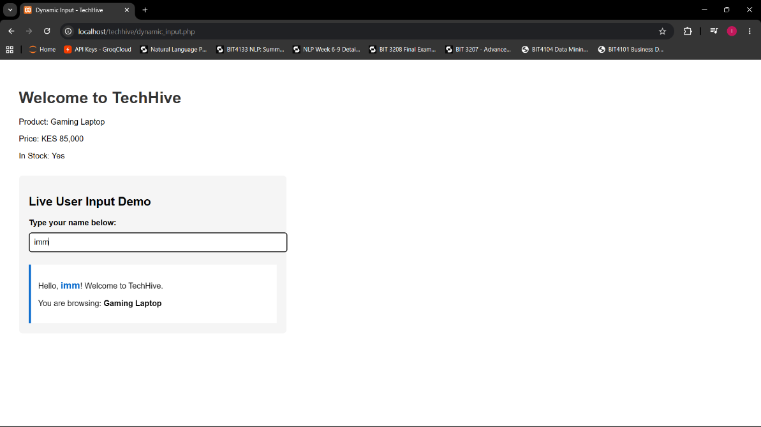

Fig 1: JavaScript was used on the frontend to validate form inputs on register.php, preventing empty or incorrectly formatted data from reaching the server. Fig 2: the password strength checker evaluates input in real time using keyboard events, giving users instant feedback by displaying weak or strong indicators before submission. Fig 3: Used PHP Syntax Practice demonstrating the use of PHP variables and echo output to dynamically display information generated on the server side. Fig 4 shows db_test.php returning a Connected Successfully message after mysqli_connect() established a connection to techhive_db, confirming PHP and MySQL are communicating correctly through XAMPP. Fig 5 shows dynamic_input.php where JavaScript DOM manipulation updates page content live as the user types without any page reload, demonstrating how frontend interactivity works independently of the server in TechHive.

Week 4: Authentication System
Title: Server-Side Components and Authentication System

Fig 1: Login form

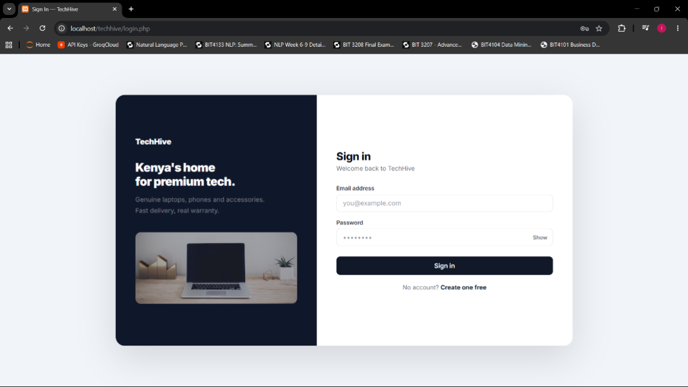

Fig 2: Registration form
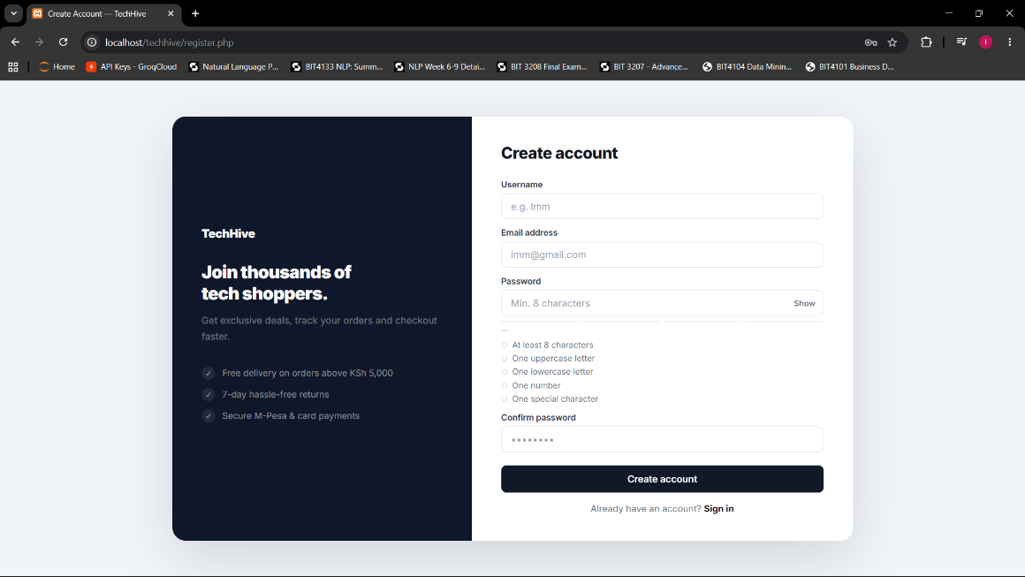

Fig 3: Simple Authentication System
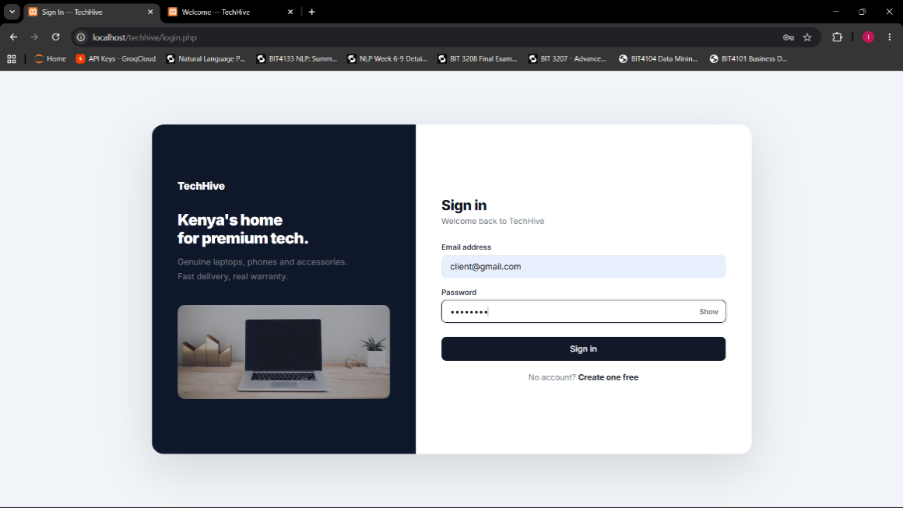

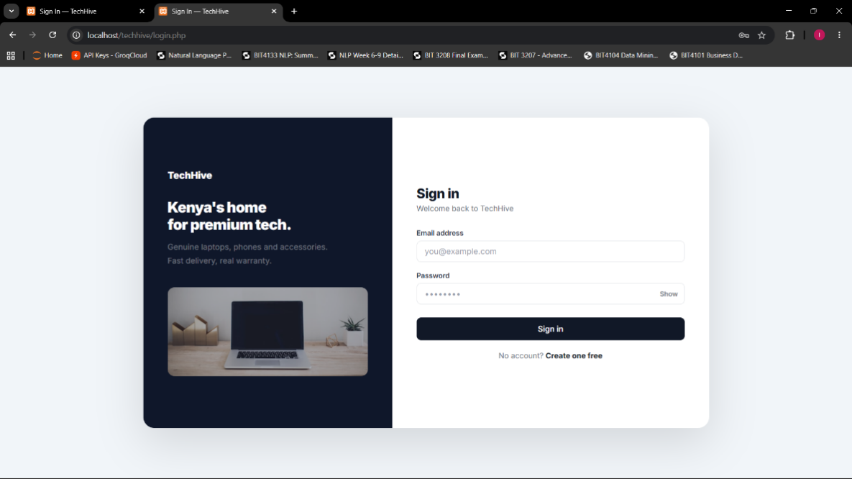

Fig 4: Backend Folder Structure
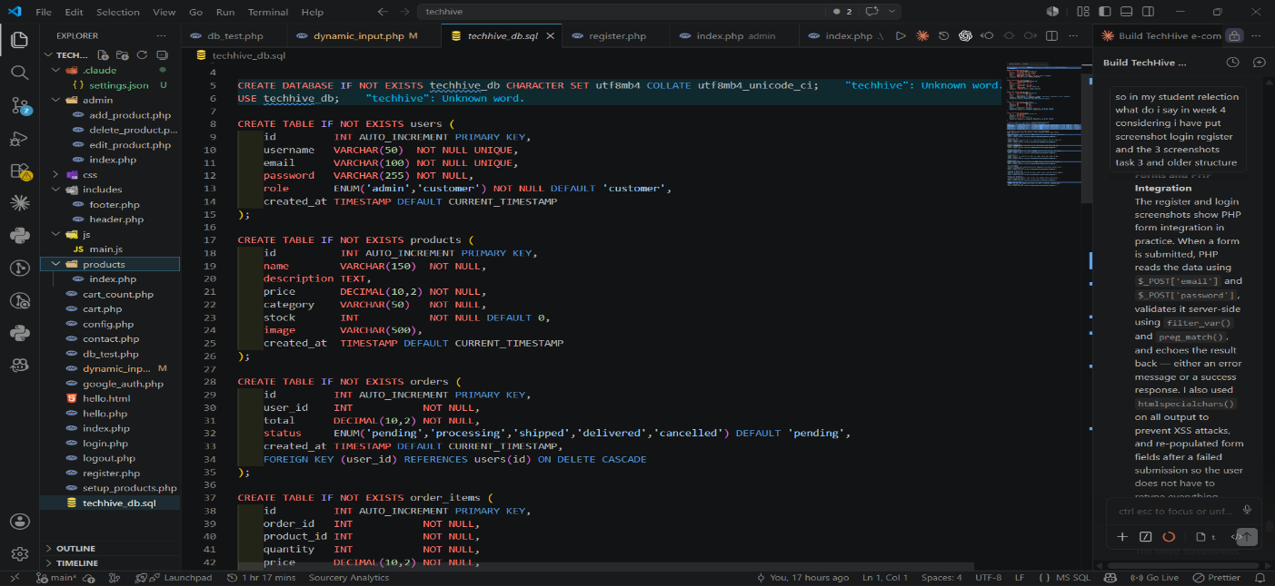

I learned server-side programming, PHP form integration, and session-based authentication. Fig 1 shows the login page where PHP reads $_POST data, queries the database, and uses password_verify() to authenticate the user. Fig 2 shows the registration page where form data is validates server-side using filter_var() and preg_match() before being stored with password_hash(). Fig 3 demonstrates the full authentication flow after a successful login, where session_start() and $_SESSION are used to store user session data, allowing the user to be redirected to the homepage after successful authentication and clicking logout triggers session_destroy() which clears the session and redirects back to login. Fig 4 shows the organised backend folder structure separating admin/, includes/, css/, and js/ for maintainability.

Week 5: Database Components and CRUD Operations

Fig 1: Database Creation

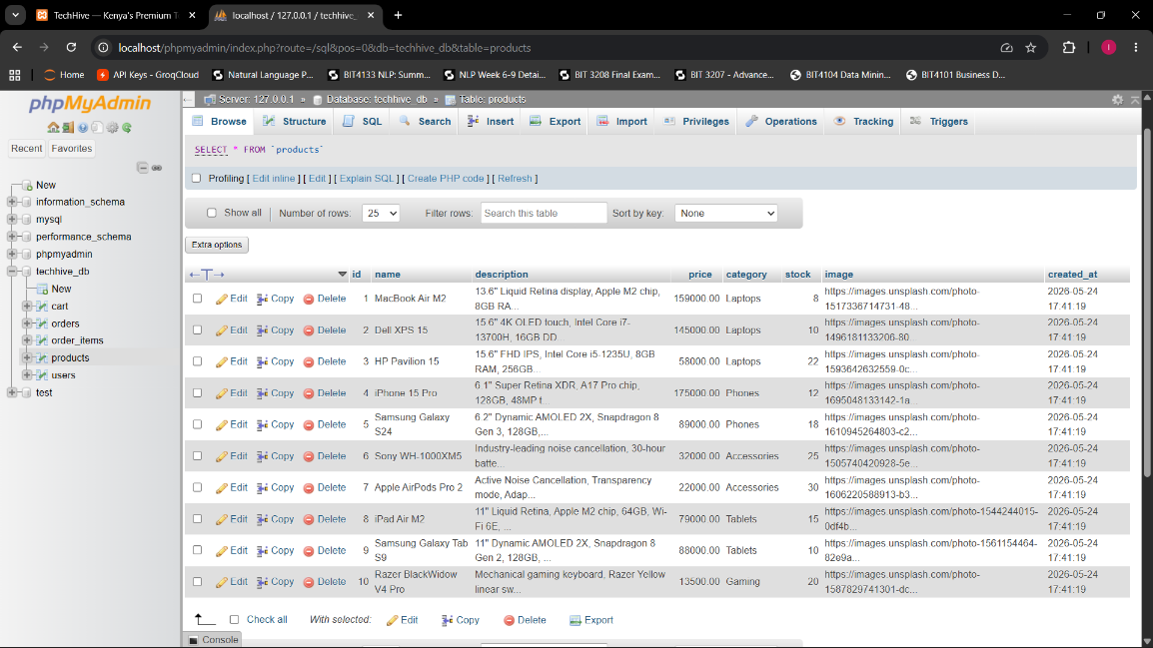

Fig 2: Creating Tables
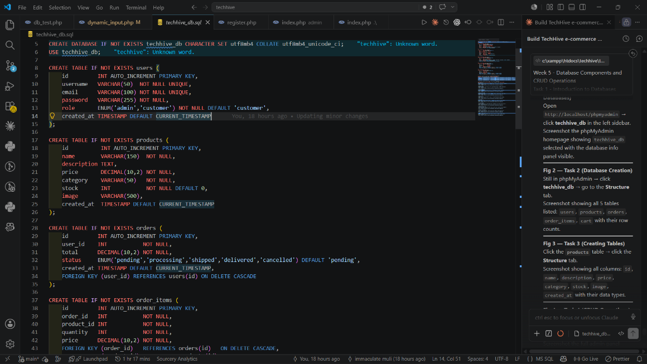

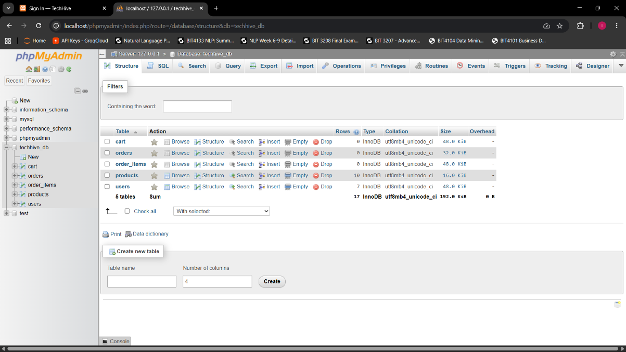

Fig 3: CRUD Operations
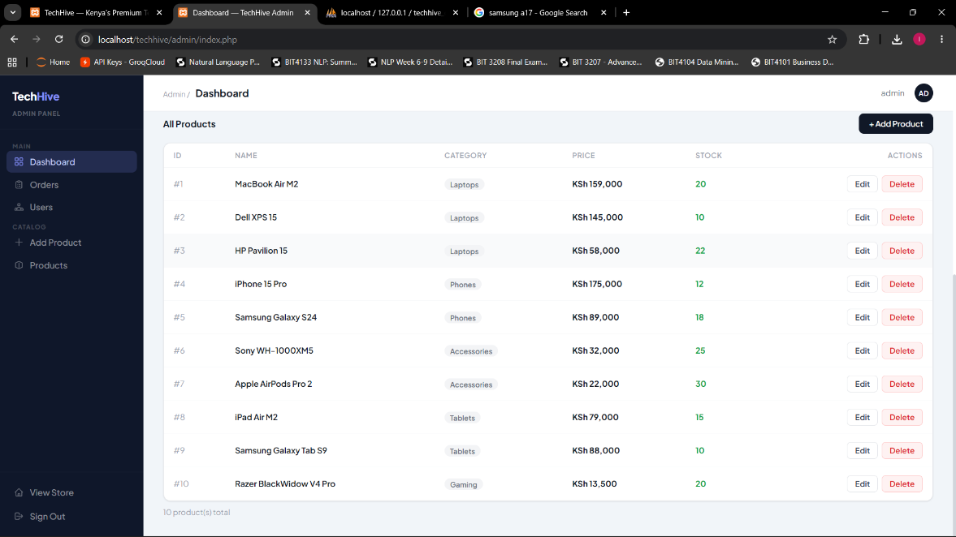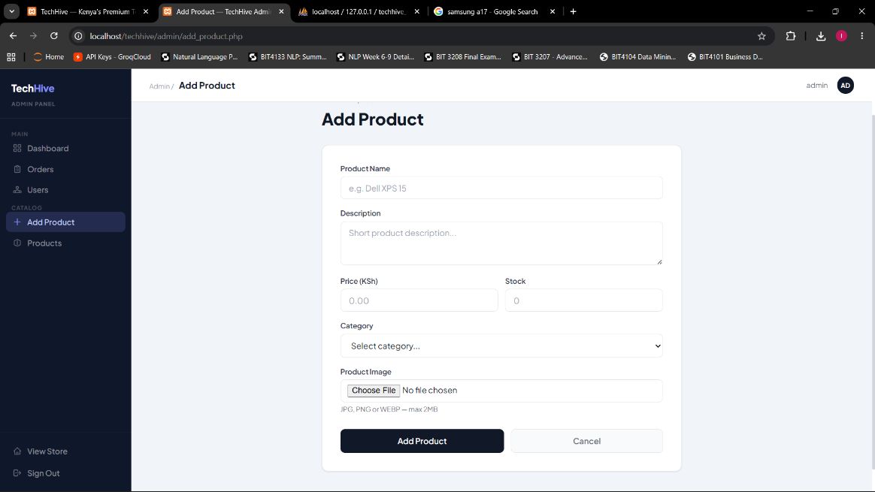

Fig 4: PHP to Database Connection
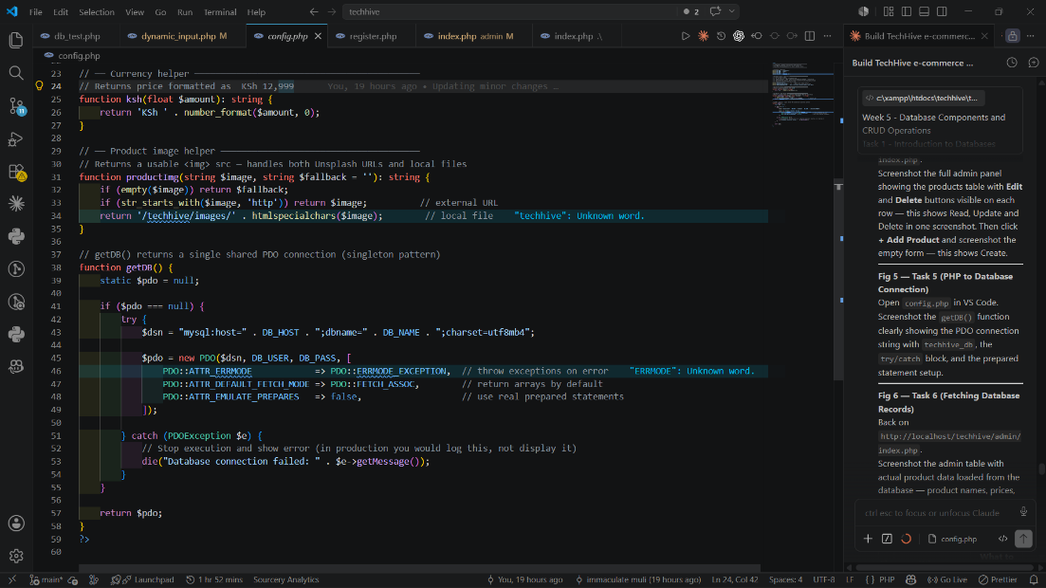

Fig 5: Fetching Database Records
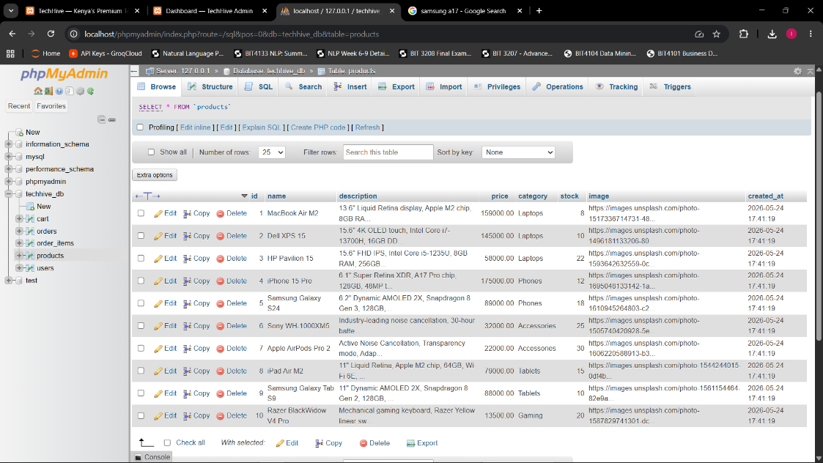
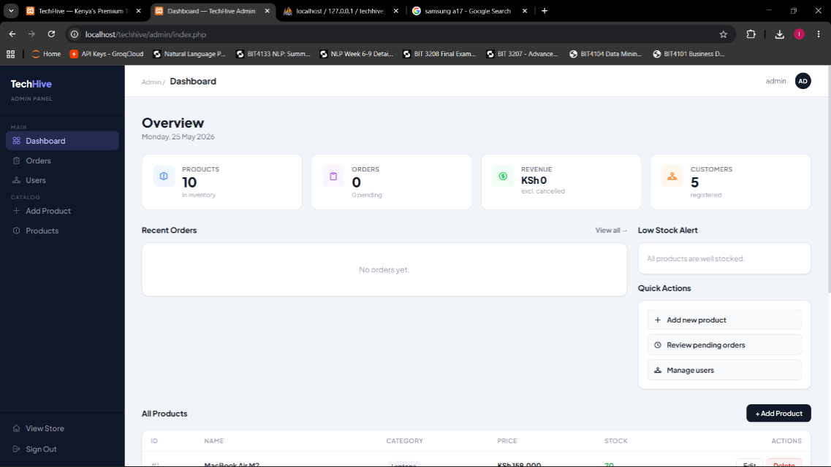

Week 5 introduced database-driven development for TechHive using MySQL through XAMPP. Fig 1 shows the techhive_db database created in phpMyAdmin containing all the required tables for the platform. Fig 2 shows the table structures created with proper data types, primary keys and foreign key relationships linking users, products, orders and cart tables together. Fig 3 demonstrates full CRUD operations working through the TechHive admin panel, allowing products to be created, read, updated and deleted dynamically from the database. Fig 4 shows the config.php file using PDO with a singleton getDB() function and prepared statements to prevent SQL injection across all database queries. Fig 5 shows products being fetched dynamically from techhive_db using SELECT queries and displayed in the admin panel, confirming successful PHP to database integration throughout TechHive.

